Unpaid Family Carers Connecting through Learning
A Guide to courses
available

2024/25

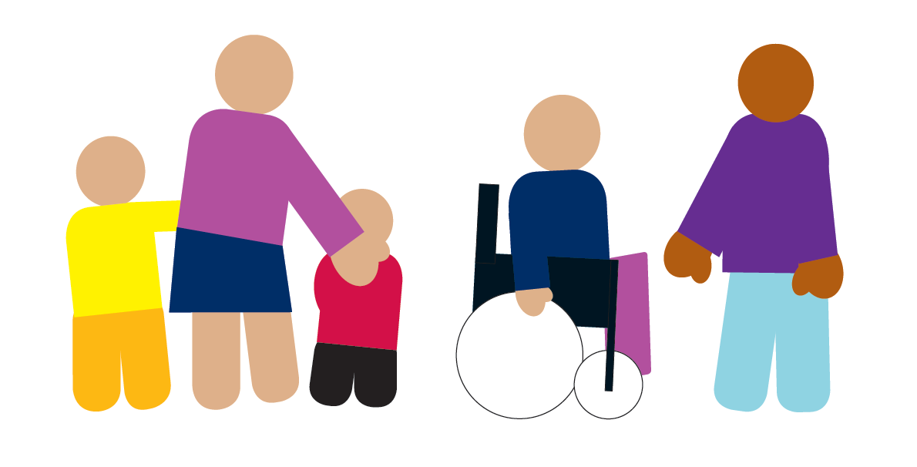
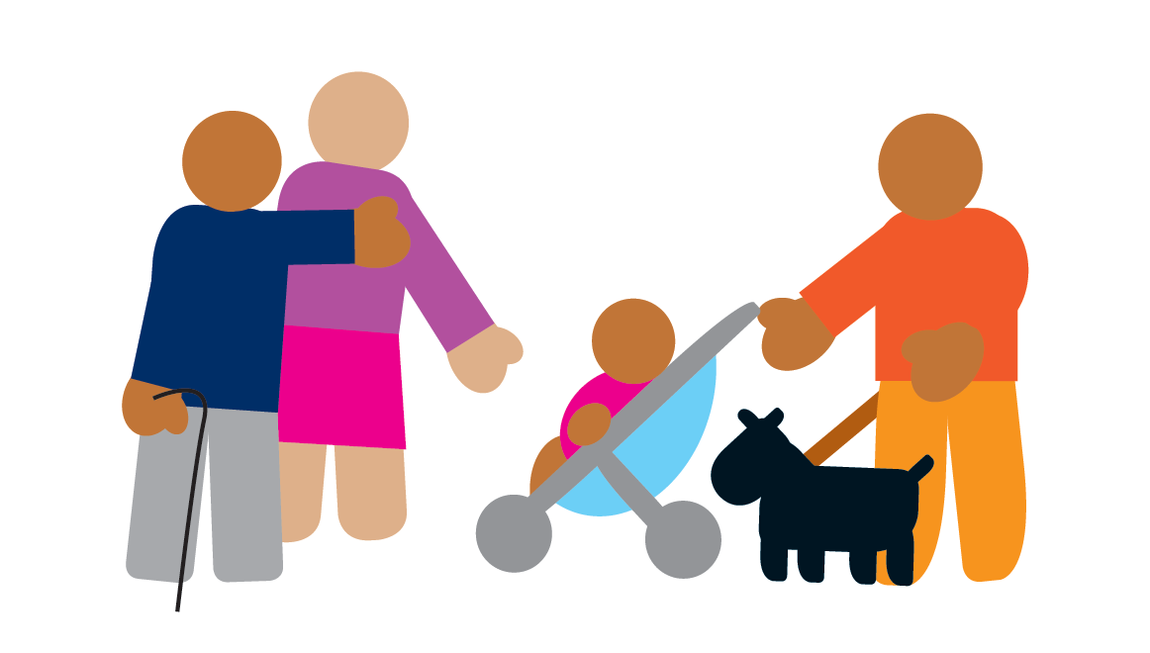


This guide includes information about training organised or paid for by Doncaster Council as well as other resources, training and support opportunities.

In this course guide a Carer is:

“A carer is anyone, an adult who looks after a family member, partner or friend who needs help because of their illness, frailty, disability, a mental health problem or an addiction and cannot cope without their support. The care they give is unpaid”.

Why is learning/training important?

Offering training is essential to make sure that any carer:
- can work safely
- continue to be good at their job and develop their skills
- develop confidence and a sense of achievement
- can meet other carers and learn from shared experiences and knowledge

But I can’t afford it!

All the training in this document is FREE to Carers that live in Doncaster

Carers are welcome to book onto classroom-based courses.
Ideally the 3-hour group session would be arranged and delivered within an existing Carers group or a newly formed group.

Contents Page

How to book courses | 3
E-Learning (Online Courses)

Carers Bite Size Wellbeing Sessions
Training on Offer | 4 to 13
Other Support  Making Space Doncaster Carers Wellbeing Service…………………………………………………………………………  National and Doncaster support links…………………………………………………………………………….. | 14  14  15
Appendices  Terms and Conditions  (For Doncaster Council classroom training courses) | 15  15

How to book courses
Classroom/Group

To check classroom dates, availability or book on a course please Ring
01302 736576 or 01302 737355
Email the following information to awft@doncaster.gov.uk:
- Your name
- Email address
- Please tell us you are a Carer when you book
- Whether or not you already have an account with the Learning Opportunities/Developing You
Someone in the workforce development team will email you back containing a Username and Password to access Developing You

Some of the classroom subjects can be tailored to be delivered in existing Carers group meetings.
E-learning – Doncaster Council

Although not for everyone, E-Learning courses can be a faster and easier way of accessing training and information. You can be accessed on mobile or fixed devices and Carers will get a printable certificate once completed.

All DMBC online training (and links to the other online training mentioned in this guide) can be found on Doncaster’s Learning Opportunities/Developing You Developing You :https://doncaster.learningpool.com/login/index.php if this link does not connect, copy and paste into your internet browser once you have got a username and password.

Bite Size Wellbeing Sessions

These sessions are designed to fit into an existing Carers group meeting, not to take up the whole session and to still allow for time for socialising and connecting with group members. To arrange email: liz.george@doncaster.gov.uk
The Training Offer

Alphabetical index of courses. Full course information for each of these courses is available on the Developing You.

Course Name | Course Aim | Course Length | Delivery Method
Autism and Learning Disability  Tier 1 | The aim of this course is to introduce and knowledge and skills to support people with Learning Disabilities and / or Autism and other spectrum related conditions and to live well. | 1 day | Classroom/to groups of Carers
Autism and Learning Disabilities Programme (Tier 2) | The aim of the course is to introduce and build deeper knowledge and skills to support people with Autism and other spectrum related conditions and Learning Disabilities to live well. | 4 days
Acquired Brain Injury | The aim of this course is to improve delegate’s understanding of acquired brain injury (including Korsakoff syndrome) and how to support individuals who have this condition. | ½ day | Group of Carers
Deaf and Hearing Impairment | The aim of the course is to provide delegates with a basic knowledge and understanding of how to communicate with and support someone who is deaf or who has a hearing impairment. | ½ day
Dementia: Essential Dementia Skills for Care Workers (Tier 1 and Tier 2) | To provide a more in depth understanding of dementia and associated issues relevant to their role in line with the Department of Health’s Dementia Education Framework, Tier 2. Attendees should have attended a dementia awareness course (or equivalent) prior to this. All front-line care workers who care/support people living with dementia, should receive training at least equivalent to Tier 2. | 4 days
(Introduction to) Deprivation of Liberty Safeguards (DOLS) | To develop the knowledge to identify a Deprivation of Liberty and to understand the responsibilities under the Deprivation of Liberty Safeguards (DoLS). | ½ day
Diabetes Awareness | To enable attendees to understand what diabetes is, how diabetes affects the body and the complications that occur in individuals with diabetes to know how to support them in the management and monitoring of their condition. | ½ day | Group of Carers
Digital / IT Skills for Carers | This session will introduce the digital support available through the Adult, Family and Community Learning (AFCL) Team to support carers to improve their digital skills for use in their own lives. | 1 hour  30 mins
Dysphagia | To provide delegates with an understanding of Dysphagia and how it occurs, particularly the signs, symptoms and problems associated with the condition and remedies that can help manage the condition. | ½ day | Group of Carers
End of Life Care Education Programme (Tier 1) | The aim of this course is to provide an understanding of what good, person-centred end of life care is. This includes the importance of good communication, symptom management, appropriate interventions, what advanced care planning is and how to support it and supporting and making the most of people’s personal and community networks. | 1 day
End of Life Care Education Programme (Tier 2) | The aim of this course is to provide an understanding of what good, person-centred end of life care is. This includes the importance of good communication, symptom management, appropriate interventions, what advanced care planning is and how to support it and supporting and making the most of people’s personal and community networks. | 3 days
Epilepsy | To enable attendees to gain a greater understanding of Epilepsy and how to support individuals who have this condition. | ½ day | Group of Carers
First Aid Awareness for Carers | This module will provide carers with the skills to make decisions and take action to perform the correct first aid. | 3 hours
Foot Care for Carers | To be able to provide basic nail care and foot hygiene that a carer would provide for themselves or the cared for person. | 2 hours | Group of Carers
Fire Safety Awareness Carers | To provide a basic understanding of fire safety, how to mitigate risk and deal with associated emergency situations. | ½ day
Food Safety Awareness for Carers | This module will introduce Food Safety and will look at Personal Hygiene, Cleaning and Contamination. | ½ day
Healthy Eating and Food Allergy Awareness for Carers | This course will enable delegates to support the people they care for to make healthy food choices and increase knowledge of food allergies/intolerances to ensure the safety of the person they care for. | 3 hours | Group of Carers
Huntingdon’s Disease | The aim of this course is to improve delegate’s understanding of Huntingdon’s Disease, treatment options and how to support individuals who have this condition. | 3 hours | Group of Carers
Introduction to Infection Prevention and Control | The aim of this course is to provide a basic understanding of types of infection, the requirement to maintain hygiene standards, and to provide the practical knowledge needed to carry out the required procedures. | 3 hours | Group of Carers
MCA: Basic Awareness | To develop an awareness of the Mental Capacity Act (‘MCA’) and its implications for your practice | ½ day
Medications Awareness in the Home for Carers | This course aims to develop an overall awareness of current legislation requirements and good practice relating to administering medication that safeguards the carer, the PA and the employer. | 3 hours | Group of Carers
Moving & Handling of People (Induction) | To ensure employees/carers have the right skills and knowledge to move and handle people in a safe manner, preventing injury/discomfort for both the client and the employee/carer. Includes: back care and load handling awareness, sitting, standing & walking, bed mobility, hoisting, community specific manoeuvres, small and wheeled equipment, lowering to floor and assisting mobile person off floor. Does not need to be repeated and can be maintained by undertaking the annual update (below). | 1 day or 3 hours tailored
Moving & Handling of People (Single-Handed Care) | To provide an awareness of normal movement and its application, ensure knowledge of selected single handed people handling techniques, ensure an understanding of the principles of single-handed hoisting, hoist components, an awareness of types and selection of slings, ensure ability to apply principles of single-handed hoisting to practical techniques of hoisting and enable staff to identify equipment that could be used for single handed care. Only available to delegates who have an up-to-date passport by completing the full induction or update (above) within the last 12 months. | 1 day
Moving & Handling of People (Update) | The update focusses on handling larger people and will provide a basic underpinning knowledge of the science of Bariatrics, ensure awareness of local guidelines/procedures for handling the Bariatric person and ensure knowledge of selected people handling techniques. Only available to delegates who have completed the full induction (above) within the last 12 months. | ½ day
Moving and Handling for Carers | General Moving and Handling techniques relating to the Carers own Caring environment. | 3 hours
Motor Neurone Disease | The aim of this course is to improve delegate’s understanding of Motor Neurone Disease, treatment options and how to support individuals who have this condition. | ½ day | Group of Carers
Multiple Sclerosis | The aim of this course is to improve delegate’s understanding of Multiple Sclerosis, treatment options and how to support individuals who have this condition. | ½ day | Group of Carers
Nutrition and Hydration (basic awareness) | The aim of this course is to improve understanding of the importance of good nutrition and hydration and how individuals can be supported in a person-centred way to eat food and drink well. | 3 hours
Oral Health (including providing personal care) | To improve knowledge and skills in delivering personal care and oral care to people in a person-centered way that maximizes their control and independence. | 1 day
Parkinson’s | This course aims to improve delegate’s understanding of Parkinson’s, treatment options and how to support individuals who have this condition. | 3 hours | Group of Carers
Pressure Ulcer Prevention and Awareness  Check outline | The aim of this course is to understand the risks associated with pressure ulcers, how to assess that risk, and how to prevent them. | 3 hours
Safeguarding Awareness for Carers | This course enables you to recognise adults who may be at risk of abuse or neglect, to understand your role and responsibilities in Safeguarding Adults and understand local policies and procedures relating to your area of work to appropriately report any concerns. | 3 hours | Group of Carers
(Caring for) Stroke Survivors | To provide the skills and knowledge to effectively care for and support individuals following a stroke. | 1 day | Group of Carers
Visual Impairment Basic Awareness | The aim of this course is to provide delegates with a basic knowledge and understanding of visual impairment and how to support someone who is blind or partially sighted. | 3 hours
(All Age) Carers | The module looks at the characteristics that define a carer, including the roles of both young and adult carers. We demonstrate how to identify somebody who might be a carer and how you can help them to find support. | 30 mins | E-learning
Autism (Intermediate Knowledge and Skills for Working with) | This module will cover the impact of autism on the family, autism in adolescence, transition to adulthood, autism in adulthood, mental health issues, helping someone get a diagnosis, how to communicate with a person with autism, how to help someone with autism get a job. | 40 mins
(Introduction to) First Aid | This module should provide you with the basic knowledge to help someone in an emergency.
Adult Obesity | By completing this module you’ll understand what it means to be obese and who’s at risk. You’ll explore why individuals become overweight or obese and the problems that being obese can cause. You’ll also learn what social care practitioners can do to support service users with weight problems. | 35 mins
Anxiety Awareness | This module introduces the signs and symptoms of anxiety and anxiety disorders. It outlines different types of anxiety disorders and provides signposts to strategies and help for managing anxiety. | 45 mins
Assistive Technology | This module will introduce you to some key elements of assistive technology and give you an overview of Telecare and Telehealth. You'll also see how appropriate assistive technology can provide solutions for a variety of people requiring support in their own homes. | 35 mins
Basic Back Care | This module is designed to raise your awareness of safe manual handling of loads and patients, as well as how to reduce the risk of injury to you or a patient. All delegates on the Moving and Handling Induction MUST complete this module first and bring evidence of completion along to the session. | 45-60mins | or Workbook
Care Act: Financial Planning and Safeguarding | This module about the Care Act 2014 examining the changes implemented regarding financial support and safeguarding. | 50 mins
Dementia Awareness (Tier 1) | This e-learning module is about raising dementia awareness for all those working in health and social care. This module meets the requirements for Tier 1 of the Dementia Training Standards Framework (Skills for Health, Health Education England, Skills for Care 2018). | 40 mins
Diabetes the fundamentals of | This course looks at what diabetes is and how those living with the condition, treat and manage it daily. | 35 mins
Dementia Friend | A Dementia Friend is somebody that learns about dementia so they can help their community. | 20 mins
Dementia Training Standards Framework (Tier 2) | This course is for those in social care, health and housing settings who provide direct care and support for people living with dementia.
Domestic Abuse Awareness | This course will help you to recognise domestic abuse and help you to understand your responsibilities in safeguarding people. | 30 mins
Drugs & Alcohol Awareness | This module aims to raise your awareness of drugs and alcohol looking at recommended guidelines for alcohol consumption, useful tips for cutting back as well as the more common drug types and their side effects and symptoms. | 20 mins
Dysphasia | This module is designed for people who work in health and social care who require a basic awareness of dysphagia. | 55 mins
Emotional Abuse | This module will help you to identify how emotional abuse affects children, the specific circumstances that put children at risk, and how emotional abuse impacts on all other types of abuse. | 20 mins
End of Life (Tier 1) | The course will provide you with an understanding of the importance of good end of life care and support. The course meets the requirements of the End-of-Life Care Framework, Tier 1. | 60 mins
End of Life Care (Tier 2) | The aim of this course is to provide an understanding of what good, person-centred end of life care is. This includes the importance of good communication, symptom management, appropriate interventions, what advanced care planning is and how to support it and supporting and making the most of people’s personal and community networks. | Approx 21 hours spread over 3 or 4 days depending on delivery method
Epilepsy Awareness | The purpose of this module is to improve the learner's understanding of epilepsy, including causes and triggers, types of seizure and methods of treatment. | 45 mins
Equalities, Diversity and Inclusion: Unconscious Bias | This module will module will help you get to grips with unconscious bias so that you can identify, acknowledge and challenge it in the workplace. | 20 mins
Food Safety Awareness | This module will provide an introduction to Food Safety and will look at Personal Hygiene, Cleaning and Contamination. | 40 mins
Friends Against Scams | This Module covers the problems with scams, types of scams, spotting a scam and scam victims and reporting a scam. | 20 mins
Healthy Lifestyles | A healthy lifestyle can have many benefits in terms of your physical and mental wellbeing. In this module we will look at the benefits of physical activity and a healthy balanced diet as well as examining ways of maintaining a healthy weight. | 20 mins
Incontinence Management | This course is for those supporting people living with incontinence in settings such as social care, residential care, health and housing. | 1 hour
Infection Prevention Control | This guidance module is intended to be the foundation for best practice for infection prevention and control.
Learning Disabilities Framework | For health and social care staff who work with people who have a learning disability. It will give you information about the core skills you need to carry out your role effectively. This course is mapped to the Skills for Health, Health Education England and Skills for Care framework. | 50 mins
Learning Disability Awareness | This module will help you to understand more about learning disability, and the difficulties that sufferers can face in everyday life. It looks at how you and your organisation can improve your written and verbal communication to ensure that your service is accessible to all. | 20 mins
Managing Medication | Managing medication is an important part of your role. It is vital that you follow guidelines to avoid mistakes. In this module we’ll look at some key areas and what you need to do. | 60 mins
Mental Health Awareness | This module will introduce mental health issues, their prevalence and the stigma attached to them. It will also look at the link between employment, homelessness, and mental health, cover the different types of mental health illness, the symptoms of psychosis and the links to alcohol and drugs and study the types of treatment available, the effects of stopping medication and discover what therapy-based treatments are. | 20 mins
Nutrition Awareness | This module will give you an introduction to nutrition. It will look at why we eat, the function of food, and explain the 'eatwell plate' and its use.
Personal Resilience | Personal resilience is an important quality for helping you to adapt and develop effective coping strategies to stressful working conditions and improve wellbeing. This module is designed to help you to think about and develop your own resilience. | 40 mins
Pressure Ulcer Prevention and Management | To understand the risks associated with pressure ulcers, how to assess that risk, and how to prevent them. | 1 hour 15 mins
Preventing Falls | The aim of this module is to give you the knowledge you need to prevent falls and to help keep people safe and independent in their own homes. | 50 mins
Safeguarding Level 1 | This module is a basic introduction to safeguarding and is aimed at all those working in health and social care settings and other care and support settings.
Self-Harm | This module looks specifically at individuals who self-harm, helping you to develop an understanding of the issues people face, and what you can do to help them. | 30 mins
Self-Neglect | This module will look at what self-neglect is and how to identify signs that someone might be at risk. | 25 mins
STOMP (Stop Over-Medication of People with a Learning | In this module, you’ll look at what the STOMP campaign is trying to achieve, why people have been over medicated, how people should be supported and what to do if you think someone is being over medicated. | 30 mins
Stress Awareness | This module is designed to give you an overview of stress awareness at work. We'll explain why stress occurs and how it can manifest itself physically and psychologically and offer practical hints and tips on how to cope with the ever-increasing demands.
Strokes | This eLearning module about Strokes will introduce you to the definitions, signs, symptoms, and prevention of strokes as well as how to work with individuals who have suffered a stroke. | 35 mins
Visual Impair | Through this module you will come to understand how we see, and what problems can arise in our visual development. You will learn how to create a safe and comfortable environment when working with people who are visually impaired.
Carers Bite size Wellbeing  Resilience | Find out what is it and learn about how you can be resilient. Get some Top Tips to take away. | 1 hour | Carers Group sessions
Carers Bite size Wellbeing  Introduction to Mindfulness | What is it and why we use it? What are the benefits of doing it? And information to take away. | 1 hour
Carers Bite size Wellbeing  Tia Chi | A talk about the health and wellbeing benefits of Tia Chi, to improve balance, strength, mobility. Do Tia Chi chair-based exercises and breathing techniques. Take away an Information sheet. | 1 hour
Carers Bite size Wellbeing  Aromatherapy | A Workshop which allows Carers to make their own essential oils and bath bombs and learn the benefits of aromatherapy. | 1 hour
Carers Bite size Wellbeing  Empowering In Nature | Take a virtual walk into nature and learn the benefits to general health and wellbeing. And make something to take home. | 1 hour
Carers Bite size Wellbeing  Drugs and Alcohol Awareness | Learn about how and why people use drugs and Alcohol as a coping strategy. | 1 hour
Carers Bite size Wellbeing  Food for Thought | Emotional eating understanding the link between Appetite and Emotions.
Carers Bite size Wellbeing  Understanding Stress and Anxiety | Linking back to empowering in nature to calm self.

Other Support and information for carers:



Doncaster Carers Wellbeing Service
Their services include Carer support, Information, advice and signposting, Community support and social inclusion.
Address: Unit 4, Stone Cross House, Doncaster Road, Kirk Sandall, Doncaster, DN3 1QS
Phone number: 01302 986900
Email: doncastercarerswellbeingservice@makingspace.co.uk

Doncaster Partnership for Carers

Supporting Carers
The Carers House
2 Regent Terrace, South Parade
Doncaster
DN1 2EE
Tel: 01302 637 566
Email: dpfc@doncastercarers.org.uk
Website: http://www.doncastercarers.org.uk/

Doncaster City Council
Visit the website: https://www.doncaster.gov.uk/services/adult-social-care/carersoffer

A Carer’s Direct Payment
A Carer can have an assessment of their needs (or Carers Conversation) in a similar way to the person that they care for can. This might help them to access a Direct Payment, which could be used to purchase training and equipment etc. to assist with staying or getting back into employment.
Contact

Doncaster Carers Wellbeing Service on 01302 986900 or
Email: DoncasterCarers.WellbeingService@makingspace.co.uk

DWP
The Department for work and Pensions has just launched a new online tool for people who are about to become carers for a relative or friend. The tool aims to help new carers think about how to manage their new care commitments and what support is available to them to balance care with work and other life commitments.
Working and supporting someone’s health or care - JobHelp

Carers UK
The UK's only national membership charity for carers, Carers UK is both a supportive community and a movement for change.
Visit their website: https://www.carersuk.org/home

Full Terms and Conditions (for Doncaster Council classroom training courses) https://www.doncaster.gov.uk/services/adult-social-care/training-and-qualifications
For any queries regarding these terms and conditions and our training events, please e-mail awft@doncaster.gov.uk or phone (01302) 736576.

There is no charge to Carers who do not attend the training they are booked on, if non- attendance is due to their caring role; we just ask that you let the Workforce Team know.

